**Assignment-5**

**Module (Bootstrap Basic & Advanced)**

**Q. What are the advantages of Bootstrap?**

🡪 Advantages of Bootstrap :-

1) Easy to Use:- Bootstrap is very easy and quite simple to

use for designing and development. Being a new frame-

work there is a lot to learn from it. It can be used with

CSS, LESS or SaaS etc.

2) An Alliance is Quite Easy:- Bootstrap is framework which

is easily integrated with bulk frameworks uninterrupted

with existing sites or the new one.

3) Fast and Time-Saving Framework:- Bootstrap is an agile

framework which is quite faster than other frameworks. It

saves time due to its standard ready-made coding blocks,

responsiveness, and cross-browser capabilities.

4) Reinforcement of Grids:- One more recommendable

feature is that bootstrap holds 12 column grid styles and

supports responsiveness, counterbalance, and embedded

elements.

5) Adhere to Basics:- Bootstrap is a framework which holds

base styling HTML elements like, tables, typography,

buttons, forms, images, lists, and icons etc.

6) A Pack of JavaScript Fundamentals:- Bootstrap supports

Javascript Components so one don't require knowledge of

scripting. It comprises JavaScript components like, tooltips,

modal windows, alerts etc. to add functionalities easily.

7) Support is Amazing:- Bootstrap is well-known for its big

support community and agile response or online solution

for the problems or queries. It also offers a great document-

ation along with examples and demo. It provides solutions

to freshers and veterans alike.

8) Bootstrap is totally Customizable:- It is developer friendly

and can be customized as per the project requirements.

Common CSS, utilities, Javascript Components, and

components can compose the appearance to create ease for

developers.

9) Agile Responsive:- Bootstrap is a fully responsive platform

supporting fluid grid layout. It crafts a mobile ready site

smoothly and easily and sets web design as per the

dimensions of the particular device.

10) Bootstrap's Consistency:- Websites or mobile applications

made with bootstrap technology can make you feel the

awesome pairing of developers and designers ensuring

consistency.

**Q. What is a Bootstrap Container, how does it work?**

🡪 Container are the most basic layout element in Bootstrap

and are required when using our default grid system.

Containers are used to contain, pad, and (sometimes)

Center the content within them. While containers can be

nested, most layouts do not required a nested container.

1) .container :- class provides a responsive fixed with

container

2) .container-fluid :- class provides a full with container

, spanning the entire width of the viewport

🡪 Fixed Container :- Use the .container class to create a

responsive, fixed-width container.

Example :-

<div class= “container”>

<h1> Some text here..</h1>

<p> Some text here....</p>

</div>

🡪 Fluid Container :- Use the .container-fluid class to

create a full width container, that will always span the

entire width of the screen.

Example :-

<div class= “container-fluid”>

<h1> Some text here..</h1>

<p> Some text here....</p>

</div>

🡪 Container Padding:- By default, containers have left

and right padding , with no top or bottom padding.

Therefore we often use spacing utilities, such as extra

Padding and margins to make them look even better.

For example:- .pt-5 means “add a large top padding.”

<div class= “container pt-5”></div>

🡪 Container Border and Color:- Borders and colors,

are also often used together with containers.

Example:-

<div class= “container p-5 my-5 border”> </div>

<div class= “container p-5 my-5 bg-dark text-

white”> </div>

<div class= “container p-5 my-5 bg-primary text-

white”> </div>

🡪 Responsive Containers: - You can use the

.container-sm|md|lg|xl classes to determine when

the container should be responsive.

The max-width of the container will change on

different screen sizes/viewports.

|  |  |  |  |  |  |  |
| --- | --- | --- | --- | --- | --- | --- |
| Class | Extra small  <576px | Small  >= 576px | Medium  >= 768px | Large  >=  992px | Extra  Large  >= 1200px | XXL  >=  1400px |
| .container-sm | 100% | 540px | 720px | 960px | 1140px | 1320px |
| .container-md | 100% | 100% | 720px | 960px | 1140px | 1320px |
| .container-lg | 100% | 100% | 100% | 960px | 1140px | 1320px |
| .container-xl | 100% | 100% | 100% | 100% | 1140px | 1320px |
| .container-xxl | 100% | 100% | 100% | 100% | 100% | 1320px |

Example:-

<div class="container-sm">.container-sm</div>  
 <div class="container-md">.container-md</div>  
 <div class="container-lg">.container-lg</div>  
 <div class="container-xl">.container-xl</div>  
 <div class="container-xxl">.container-xxl</div>

Example :-

<!DOCTYPE html>

<html lang="en">

<head>

<meta charset="UTF-8">

<meta name="viewport" content="width=device-width, initial-scale=1.0">

<link href="https://cdn.jsdelivr.net/npm/bootstrap@5.3.2/dist/css/bootstrap.min.css" rel="stylesheet">

<script src="https://cdn.jsdelivr.net/npm/bootstrap@5.3.2/dist/js/bootstrap.bundle.min.js"></script>

<title> Container Example in Bootstrap. </title>

</head>

<body>

<div class="container">

<h1> Example of Fixed Container..! </h1>

<p> Lorem ipsum dolor sit amet consectetur, adipisicing elit. Minus quasi voluptatum quidem veniam hic fugit

illo exercitationem alias eligendi unde.</p>

</div>

<div class="container_fluid">

<h1> Example of Fluid Container..! </h1>

<p> Lorem ipsum dolor sit amet consectetur, adipisicing elit. Minus quasi voluptatum quidem veniam hic fugit

illo exercitationem alias eligendi unde.</p>

</div>

<div class="container pt-5">

<h1> Example of Fluid Container..! </h1>

<p> Lorem ipsum dolor sit amet consectetur, adipisicing elit. Minus quasi voluptatum quidem veniam hic fugit

illo exercitationem alias eligendi unde.</p>

</div>

<div class="container p-5 my-5 border">

<h1> Example of Fixed Container..! </h1>

<p> Lorem ipsum dolor sit amet consectetur, adipisicing elit. Minus quasi voluptatum quidem veniam hic fugit

illo exercitationem alias eligendi unde.</p>

</div>

<div class="container p-5 my-5 bg-dark text-white">

<h1> Example of Fixed Container..! </h1>

<p> Lorem ipsum dolor sit amet consectetur, adipisicing elit. Minus quasi voluptatum quidem veniam hic fugit

illo exercitationem alias eligendi unde.</p>

</div>

<div class="container p-5 my-5 bg-primary text-white">

<h1> Example of Fixed Container..! </h1>

<p> Lorem ipsum dolor sit amet consectetur, adipisicing elit. Minus quasi voluptatum quidem veniam hic fugit

illo exercitationem alias eligendi unde.</p>

</div>

</body>

</html>

Output:-

**Q. What are the default Bootstrap text settings?**

🡪 Bootstrap uses a default font-size of 1rem(16px by default)

and its line-height is 1.5.

🡪 In addition, all <p> elements have margin-top:0 and

Margin-bottom: 1rem(16px by default)

🡪HTML headings(<h1> to <h6>) with a bolder font-

weight and a responsive font-size. You can use .h1 and

.h6 classes on other elements to make them behave as

headings if you want.

🡪 Display headings are used to stand out more than

normal headings (large font-size and lighter font-

weight), and there are six classes to choose form:

.display-1 to .display-6.

🡪 The HTML <small> element (and the .small class) is

used to create a smaller, secondary text in any heading.

🡪 The HTML <mark> element and .mark with a yellow

background color and some padding:

🡪 The HTML <abbr> element with a dotted border

Bottom and a cursor with question mark on hover.

Example :-

<!DOCTYPE html>

<html lang="en">

<head>

<meta charset="UTF-8">

<meta name="viewport" content="width=device-width, initial-scale=1.0">

<link href="https://cdn.jsdelivr.net/npm/bootstrap@5.3.2/dist/css/bootstrap.min.css" rel="stylesheet">

<script src="https://cdn.jsdelivr.net/npm/bootstrap@5.3.2/dist/js/bootstrap.bundle.min.js"></script>

<title>Document</title>

</head>

<body>

<!-- Bootstrap Text Default Setting Example -->

<h3> Default Bootstrap text Setting.</h3>

<p> Lorem ipsum dolor sit amet consectetur, adipisicing elit. Quod perspiciatis mollitia laborum porro possimus ab

iure eligendi. Aperiam, fugiat consequatur.</p>

<!-- Example of HTML headings (<h1> to <h6>) in Bootstrap. -->

<div class="container">

<h1> Bootstrap heading </h1>

<h2> Bootstrap heading </h2>

<h3> Bootstrap heading </h3>

<h4> Bootstrap heading </h4>

<h5> Bootstrap heading </h5>

<h6> Bootstrap heading </h6>

</div>

<!-- .h1 to .h6 classes on other elements -->

<div class="container mt-3">

<p class="h1"> Bootstrap heading </p>

<p class="h2"> Bootstrap heading </p>

<p class="h3"> Bootstrap heading </p>

<p class="h4"> Bootstrap heading </p>

<p class="h5"> Bootstrap heading </p>

<p class="h6"> Bootstrap heading </p>

</div>

<!--

.display-1 to display-6 classes example -->

<div>

<h1 class="display-1"> Display 1</h1>

<h1 class="display-2"> Display 2</h1>

<h1 class="display-3"> Display 3</h1>

<h1 class="display-4"> Display 4</h1>

<h1 class="display-5"> Display 5</h1>

<h1 class="display-6"> Display 6</h1>

</div>

</body>

</html>

Output :-

**Q. What do you know about the Bootstrap Grid System?**

🡪 Bootstrap’s grid system uses a series of containers, rows,

and columns to layout and align content. It’s built with flex

box and is fully responsive.

🡪 Bootstrap’s grid system allows up to 12 columns across the

page. If you do not want to use 12 column individually,

you can group the columns together to create wider

columns.

🡪 Grid Classes :- The Bootstrap grid system has four classes

1) xs (for Phones- screens less than 768px wide)

2) sm (for tablets – screens equal to or greater than 768px

wide)

3) md ( for small laptops – screens equal to or greater than

992px wide)

4) lg (for laptops and desktops – screens equal to greater

than 1200px wide)

The classes above can be combined to create more

dynamic and flexible layouts.

🡪 Grid System Rules :-

1) Rows must be placed within a .container (fixed-

width) or .container-fluid (full- width ) for proper

alignment and padding.

2) Use rows to create horizontal groups of columns.

3) Content should be placed within columns, and

only columns may be immediate children of rows.

4) Predefined classes like .row and .col-sm-4 are

available for quickly making grid layouts.

5) Columns create gutters (gaps between column

content) via padding. That padding is offset in rows

for the first and last column via negative margin on

.rows.

6) Grid columns are created by specifying the number

12 available columns you wish to span. For example

three equal columns would use three .col-sm-4

7) Column widths are in percentage, so they are

always fluid and sized relative to their parent

element.

Example:-

<!DOCTYPE html>

<html lang="en">

<head>

<meta charset="UTF-8">

<meta name="viewport" content="width=device-width, initial-scale=1.0">

<link rel="stylesheet" href="https://maxcdn.bootstrapcdn.com/bootstrap/3.4.1/css/bootstrap.min.css">

<script src="https://ajax.googleapis.com/ajax/libs/jquery/3.7.1/jquery.min.js"></script>

<script src="https://maxcdn.bootstrapcdn.com/bootstrap/3.4.1/js/bootstrap.min.js"></script>

<title>Document</title>

</head>

<body>

<div class="container">

<h2>Example of Bootstrap Grid </h2>

<div class="row">

<div class="col-sm-6" style="background-color:yellow;">

<p>Lorem ipsum dolor sit amet consectetur, adipisicing elit. Officiis, perferendis?</p>

</div>

<div class="col-sm-6" style="background-color:pink;">

<p>Lorem ipsum dolor sit amet, consectetur adipisicing elit. Debitis voluptas labore veritatis nesciunt expedita natus dolor officia corporis non omnis.</p>

</div>

</div>

</div>

</div>

</body>

</html>

Output:-

**Q. What is the difference between Bootstrap 4 and**

**Bootstrap 5**

🡪

|  |  |  |
| --- | --- | --- |
| Feature | Bootstrap 4 | Bootstrap 5 |
| Default CSS  Framework | Sass | Sass |
| CSS file structure | Multiple CSS files | Single CSS file |
| Grid System | Uses floats for layout | Uses CSS flexbox for layout |
| Utility classes | Uses classes like ‘.col-’ and ‘.d-’ | Uses classes like ‘.col-’and ‘.d-’ |
| JavaScript dependencies | JQuery and Popper.js | No JQuery or Popper.js dependencies |
| Customization options | Less customization options | Increased customization options with SASS |
| Reboot CSS | Based on Normalize.css | Improved and streamlined reboot CSS |
| Responsive breakpoints | 5 break points: xs, sm, md, lg ,xl | 4 breakpoints: sm, md, lg, xl |
| Typography | Font size units are in pixels | Font size units are in rems |
| Components | Similar components as Bootstrap 3 | Refined and new comoponents |
| Documentation | Well-documented, separate documentation sites | Combined and documentation for  CSS and JS |

**Q. What is Button Group, and what is the class for a basic**

**Button Group?**

🡪 “Button Groups” in Bootstrap is a class name of “btn-

group” which is used to create a series of buttons in

groups (without spaces) vertically or horizontally.

🡪 This is the basic syntax of the button group class where

each button has its own class of “btn”.

Syntax:-

<div class= “btn-group”>

<button type= “button” class= “btn”>

Click</button>

<div>

🡪 Bootstrap allows you to add styles to your buttons using

the following classes.

1) .btn-default

2) .btn-primary

3) .btn-success

4) .btn- info

5) .btn-warning

6) .btn-danger

7) .btn-link

Example:-

<!DOCTYPE html>

<html lang="en">

<head>

<meta charset="UTF-8">

<meta name="viewport" content="width=device-width, initial-scale=1.0">

<link rel="stylesheet" href="https://maxcdn.bootstrapcdn.com/bootstrap/4.5.2/css/bootstrap.min.css">

<script src="https://ajax.googleapis.com/ajax/libs/jquery/3.5.1/jquery.min.js">

</script>

<script src="https://cdnjs.cloudflare.com/ajax/libs/popper.js/1.16.0/umd/popper.min.js">

</script>

<script src="https://maxcdn.bootstrapcdn.com/bootstrap/4.5.2/js/bootstrap.min.js"></script>

<title>Document</title>

<body>

<div class="btn-group btn-group-lg">

<button type="button" class="btn btn-danger">Click</button>

<button type="button" class="btn btn-warning">Click</button>

<button type="button" class="btn btn-success">Click</button>

</div>

<div class="btn-group">

<button type="button" class="btn btn-danger">Click</button>

<button type="button" class="btn btn-warning">Click</button>

<button type="button" class="btn btn-success">Click</button>

</div>

<div class="btn-group btn-group-sm">

<button type="button" class="btn btn-danger">Click</button>

<button type="button" class="btn btn-warning">Click</button>

<button type="button" class="btn btn-success">Click</button>

</div>

<div class="btn-group btn-group-xs">

<button type="button" class="btn btn-danger">Click</button>

<button type="button" class="btn btn-warning">Click</button>

<button type="button" class="btn btn-success">Click</button>

</div>

</div>

</body>

</html>

Output :-



**Q. How can you use Bootstrap to make thumbnails?**

🡪 A lot of sites need a way to lay out images, videos, text,

etc, in a grid, and Bootstrap has an easy way to do this

with thumbnails. To create thumbnails using Bootstrap –

🡪 Add an <a> tag with the class of .thumbnails around

An image.

🡪 This adds four pixels of padding and a Gray border.

🡪 On hover, an animated glow outlines the image.

Example :-

<!DOCTYPE html>

<html lang="en">

<head>

<meta charset="UTF-8">

<meta name="viewport" content="width=device-width, initial-scale=1.0">

<link rel="stylesheet" href="https://maxcdn.bootstrapcdn.com/bootstrap/3.4.1/css/bootstrap.min.css">

<script src="https://ajax.googleapis.com/ajax/libs/jquery/3.7.1/jquery.min.js"></script>

<script src="https://maxcdn.bootstrapcdn.com/bootstrap/3.4.1/js/bootstrap.min.js"></script>

<title> Thunbnail images </title>

</head>

<body>

<h3 style="color: green;"> Bootstrap thumbnails </h3>

<div class="row">

<div class="col-md-4">

<div class="thumbnail">

<a href="#">

<img src="/Users/arnavpandav/Downloads/ginger-cat-arm-sofa.jpg" style="width: 100%;">

<div class="caption">

<p> Lorem ipsum dolor sit amet consectetur adipisicing elit. Reprehenderit, ad. Quibusdam

blanditiis voluptate sit illum voluptatum veritatis praesentium rem, ratione ipsam! Nulla

iste quo recusandae, hic cumque illo? Culpa, quasi.</p>

</div>

</a>

<div><button type="button" class="btn btn-success"> Learn More</button> </div>

</div>

</div>

<div class="col-md-4">

<div class="thumbnail">

<a href="#">

<img src="/Users/arnavpandav/Downloads/ginger-cat-arm-sofa.jpg" style="width: 100%;">

<div class="caption">

<p> Lorem ipsum dolor sit amet consectetur adipisicing elit. Reprehenderit, ad. Quibusdam

blanditiis voluptate sit illum voluptatum veritatis praesentium rem, ratione ipsam! Nulla

iste quo recusandae, hic cumque illo? Culpa, quasi.</p>

</div>

</a>

<div><button type="button" class="btn btn-success"> Learn More</button> </div>

</div>

</div>

<div class="col-md-4">

<div class="thumbnail">

<a href="#">

<img src="/Users/arnavpandav/Downloads/ginger-cat-arm-sofa.jpg" style="width: 100%;">

<div class="caption">

<p> Lorem ipsum dolor sit amet consectetur adipisicing elit. Reprehenderit, ad. Quibusdam

blanditiis voluptate sit illum voluptatum veritatis praesentium rem, ratione ipsam! Nulla

iste quo recusandae, hic cumque illo? Culpa, quasi.</p>

</div>

</a>

<div><button type="button" class="btn btn-success"> Learn More</button> </div>

</div>

</div>

</div>

</body>

</html>

Output:-

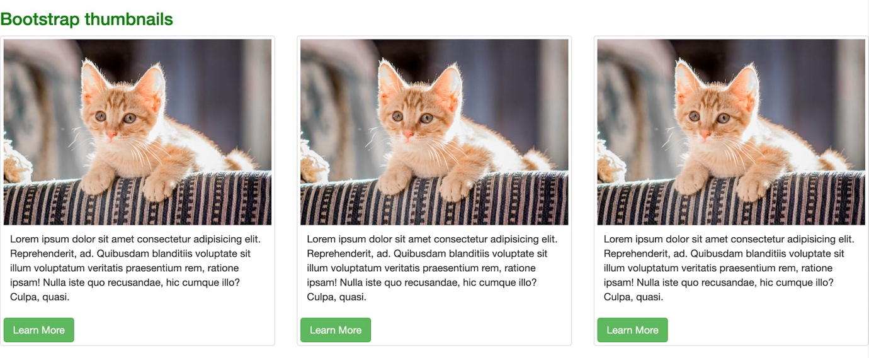

**Q. In Bootstrap 4, what is flexbox?**

🡪 The Flexible Box Layout Module, makes it easier flexible

responsive layout structure without using float or

positioning.

🡪 To create a flexbox container and transform direct children

into flex items, use the d-flex class.

Example:-

<!DOCTYPE html>

<html lang="en">

<head>

<meta charset="UTF-8">

<meta name="viewport" content="width=device-width, initial-scale=1.0">

<link rel="stylesheet" href="https://cdn.jsdelivr.net/npm/bootstrap@4.6.2/dist/css/bootstrap.min.css">

<script src="https://cdn.jsdelivr.net/npm/jquery@3.7.1/dist/jquery.slim.min.js"></script>

<script src="https://cdn.jsdelivr.net/npm/popper.js@1.16.1/dist/umd/popper.min.js"></script>

<script src="https://cdn.jsdelivr.net/npm/bootstrap@4.6.2/dist/js/bootstrap.bundle.min.js"></script>

<title>Document</title>

</head>

<body>

<div class="container mt-3">

<h2> Flex</h2>

<p> To create a flexbox container and transform direct children into flex items, use the d-flex class </p>

<div class="d-flex p-3 bg-secondary text-white">

<div class="p-2 bg-info"> Flex item1 </div>

<div class="p-2 bg-warning"> Flex item2 </div>

<div class="p-2 bg-primary"> Flex item3 </div>

</div>

</div>

<div class="container">

<h2> Inline Flex</h2>

<p> To create an inline flexbox container, use the d-inline flex class</p>

<div class="d-inline-flex p-3 bg-secondary text-white">

<div class="p-2 bg-info"> Flex item1 </div>

<div class="p-2 bg-warning"> Flex item2 </div>

<div class="p-2 bg-primary"> Flex item3 </div>

</div>

</div>

<div class="container">

<h2> Horizontal Direction flex</h2>

<p> Use .flex-row to make the flex items appear side by side(default) </p>

<div class="d-flex flex-row bg-secondary text-white">

<div class="p-2 bg-info"> Flex item1 </div>

<div class="p-2 bg-warning"> Flex item2 </div>

<div class="p-2 bg-primary"> Flex item3 </div>

</div>

<br>

<p> Use .flex-row reverse to right-align the direction:</p>

<div class="d-flex flex-row-reverse bg-secondary text-white">

<div class="p-2 bg-info"> Flex item1 </div>

<div class="p-2 bg-warning"> Flex item2 </div>

<div class="p-2 bg-primary"> Flex item3 </div>

</div>

</div>

<div class="container mt-3">

<h2>Vertical Direction</h2>

<p>Use .flex-column to display the flex items vertically (on top of each other):</p>

<div class="d-flex flex-column mb-3">

<div class="p-2 bg-info">Flex item 1</div>

<div class="p-2 bg-warning">Flex item 2</div>

<div class="p-2 bg-primary">Flex item 3</div>

</div>

<p>Use .flex-column-reverse to reverse the vertical direction:</p>

<div class="d-flex flex-column-reverse">

<div class="p-2 bg-info">Flex item 1</div>

<div class="p-2 bg-warning">Flex item 2</div>

<div class="p-2 bg-primary">Flex item 3</div>

</div>

</div>

</body>

</html>

Output :-

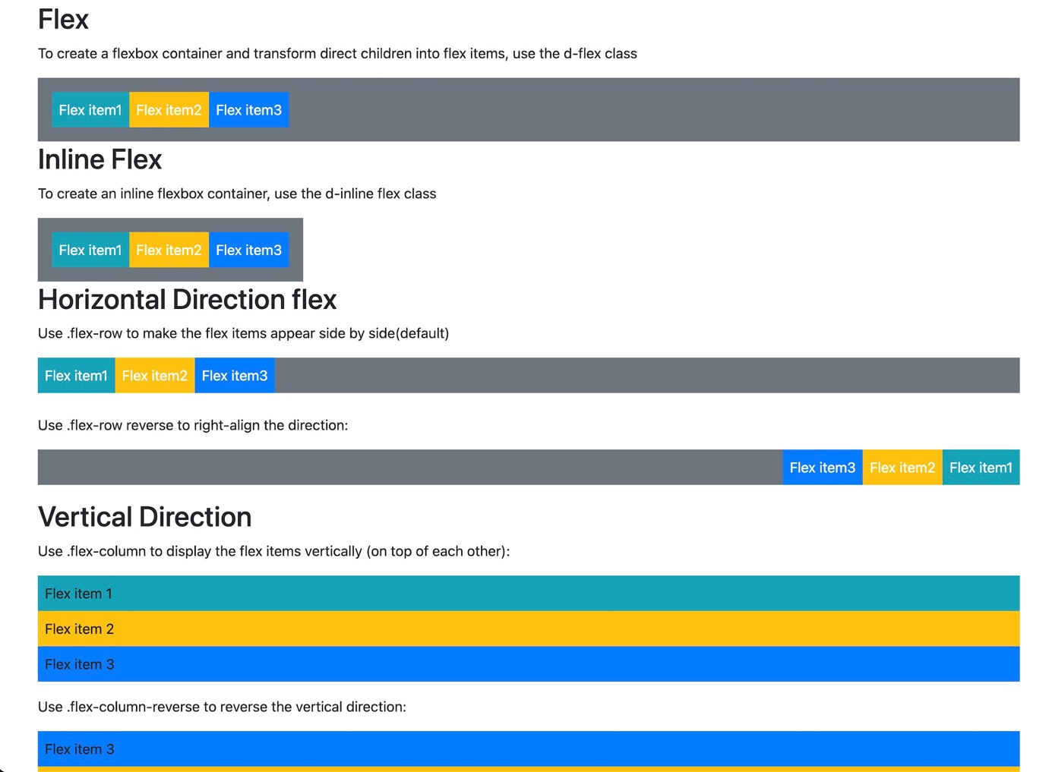

**Q. How can one create an alert in Bootstrap?**

🡪 Bootstrap provides an easy way to create predefined

alert messages:

🡪 Alerts are created with the .alert class, followed by one of

the four contextual classes .alert-success, .alert-info, .alert-

warning or .alert-danger :

🡪 Alert Links class to any links inside the alert box to create

“matching colored links”

Example :-

<!DOCTYPE html>

<html lang="en">

<head>

<meta charset="UTF-8">

<meta name="viewport" content="width=device-width, initial-scale=1.0">

<link rel="stylesheet" href="https://maxcdn.bootstrapcdn.com/bootstrap/3.4.1/css/bootstrap.min.css">

<script src="https://ajax.googleapis.com/ajax/libs/jquery/3.7.1/jquery.min.js"></script>

<script src="https://maxcdn.bootstrapcdn.com/bootstrap/3.4.1/js/bootstrap.min.js"></script>

<title>Document</title>

</head>

<body>

<div class="container">

<h2>Alerts</h2>

<div class="alert alert-success">

<strong>Success!</strong> This alert box could indicate a successful or positive action.

</div>

<div class="alert alert-info">

<strong>Info!</strong> This alert box could indicate a neutral informative change or action.

</div>

<div class="alert alert-warning">

<strong>Warning!</strong> This alert box could indicate a warning that might need attention.

</div>

<div class="alert alert-danger">

<strong>Danger!</strong> This alert box could indicate a dangerous or potentially negative action.

</div>

</div>

<!-- Alert Links -->

<div class="container">

<h2>Alert Links</h2>

<p>Add the alert-link class to any links inside the alert box to create "matching colored links".</p>

<div class="alert alert-success">

<strong>Success!</strong> You should <a href="#" class="alert-link">read this message</a>.

</div> ̰

<div class="alert alert-info">

<strong>Info!</strong> You should <a href="#" class="alert-link">read this message</a>.

</div>

<div class="alert alert-warning">

<strong>Warning!</strong> You should <a href="#" class="alert-link">read this message</a>.

</div>

<div class="alert alert-danger"> ̰

<strong>Danger!</strong> You should <a href="#" class="alert-link">read this message</a>.

</div>

</div>

</body>

</html>

Output :-

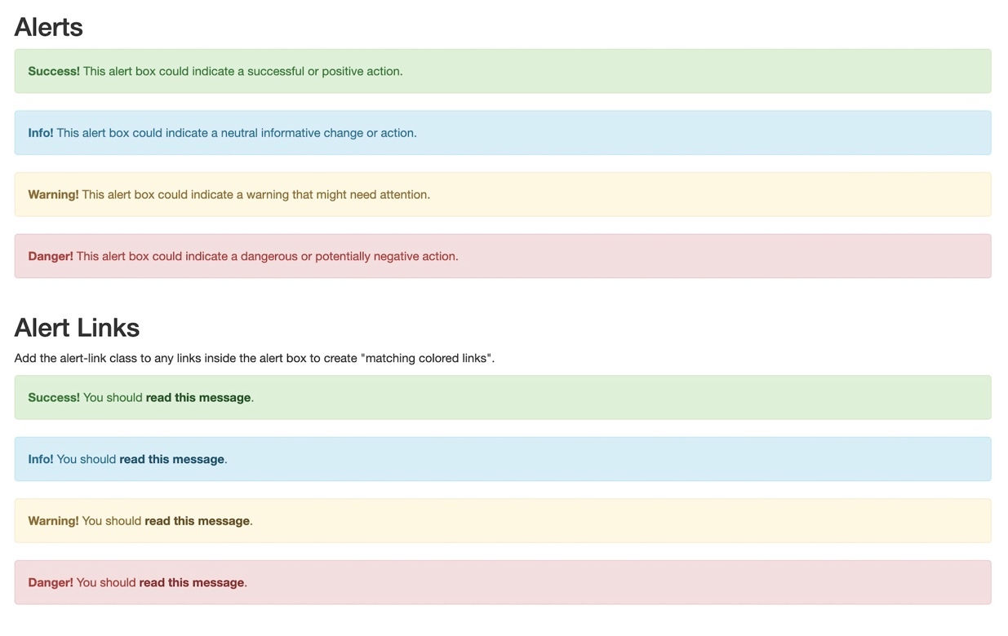

**Q. What is a Bootstrap card and how would you create**

**one?**

🡪 A card in Bootstrap 5 is a bordered box with some padding

around its content. It includes options for headers, footers,

content, colors , etc.

🡪 Use .card-title to add titles to any heading element. The

.card-text class is used to remove bottom margins for a<p>

element if it is the last child (or the only one ) inside

.card- body. The .card-link class adds a blue color to any

link, and a hover effect.

🡪 Add .card-img-top or .card-img-bottom to an <img> to

place the image at the top or at the bottom inside the card.

Example :-

<!DOCTYPE html>

<html lang="en">

<head>

<meta charset="UTF-8">

<meta name="viewport" content="width=device-width, initial-scale=1.0">

<link href="https://cdn.jsdelivr.net/npm/bootstrap@5.3.2/dist/css/bootstrap.min.css" rel="stylesheet">

<script src="https://cdn.jsdelivr.net/npm/bootstrap@5.3.2/dist/js/bootstrap.bundle.min.js"></script>

<title>Document</title>

</head>

<body>

<div class="container mt-3">

<div class="card" style="width: 300px;">

<img class="card-img-top" src="/Users/arnavpandav/Downloads/img_avatar3.png" alt="Card image"

style="width:100%">

<div class="card-body">

<h4 class="card-title">Richard Taylor </h4>

<p class="card-text"> Some Text</p>

<a href="#" class="btn btn-primary"> See Profile</a>

</div>

</div>

</div>

</body>

</html>

Output :-

